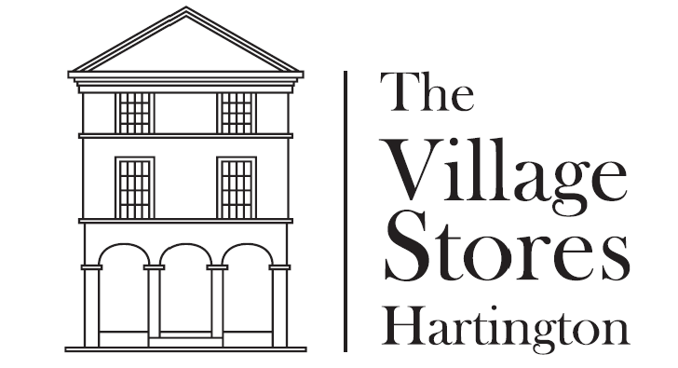
Pies Etc…
Small Pork Pie / Medium Pork Pie - £1.25 / £2.45
Huntsman’s Pie - £2.65
(Layers of chicken, pork pie meat and stuffing encased in a hot water crust case)
Peak Pasty - £2.65
(Very much like a Cornish pasty, but locally made and guaranteed to fill you up!)
Peppered Steak Slice - £1.50
Sausage Roll - £1.00
Spinach and Feta Pasty - £1.95
Cheese and Onion Pasty - £1.50

Salad Box - £2.25
Tubs of Hummus (Including Carrot Batons) - £2.30
Tubs of Coleslaw - £1.30
Food intolerance and Allergen information is available – please ask staff for more information

